Josiah Roske
CS-250
12/7/25
Prof. Krupa
Final Project
Over the past couple of months, our scrum team was tasked with completing a new site design for SNHU travel. The team consisted of different roles that worked in conjunction, using agile methods to deliver the project on time. Our team was composed of a product owner, scrum master, tester and developer, where each member played different parts in the process of the project's development, which led to the success of the project's rollout.
Starting with the product owner, they act as middle man between the client and the scrum team, developing the overall vision of the product, creating goals, developing a product backlog and user stories, for the team to use. Towards the beginning of the product's lifecycle, the product owner met with potential travel clients to get ideas for potential features of the site. Afterwards, they developed the product backlog of user stories, that would then be used by the team to be used as a reference while they make the test cases and develop the working features. The scrum master acts as leader for the rest of the scrum team, but a leader whose main goal is to serve the people they lead. They are there to teach the team on agile methods and help ensure the team has as little distractions as possible and to be as efficient as possible. One of their major responsibilities is leading the scrum meetings, by simply posing the questions and allowing the team members to discuss amongst each other. By doing this it helps foster a collaborative effort among the team.
Now going to the development team, this consisted of testers and developers, who worked together to create a quality, working product. In an agile team, the tester is hands-on throughout the project's lifecycle, and creates the test cases to ensure the product works the way it is intended to. During this project, the tester worked closely with the product owner and used the user stories to develop test cases that explained how the features should function. These test cases were then passed along to the developers as another form of reference as they work on the items within the product backlog. During this project, the testers received the user stories from the product owner, where they then needed to develop the test cases for the user stories. Finally, we have the developers, they are self organizing members of the team who work on the product and ultimately decide how they will approach the problem. They work closely amongst each other and the testers, as they use the test cases and user stories to develop the product and oftentimes, will receive input that makes changes to the work they have already done. In a recent event, the product owner made changes to the travel site, looking to adjust the focus of the types of travel packages. The development team then needed to act quickly and adjust what they had done previously to meet the new requirements.
During the development of the project, the team was tasked with a limited timeline to complete the product. The use of user stories helps the team meet this deadline. The use of an agile approach helped the completion of these items. The product owner met with potential clients to get ideas of features and their importance. They developed the user stories of the features where they broke down the stories into smaller parts. A backlog that ranked the stories and three crucial questions: “As a (type of user),” “I want to (perform a task)” and “achieve a goal.”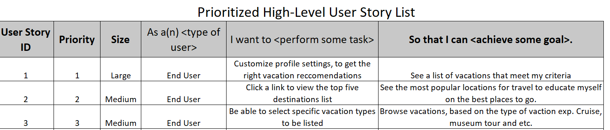 And then built off of those questions to create bulleted points for an acceptance criteria. With the ranking system, these stories then could be prioritized in a manner where the most important would be focused on in earlier sprints while the others would be backlogged until later. This focus helped shape the test cases, created by the tester, and later the creation of the stories from the developers.
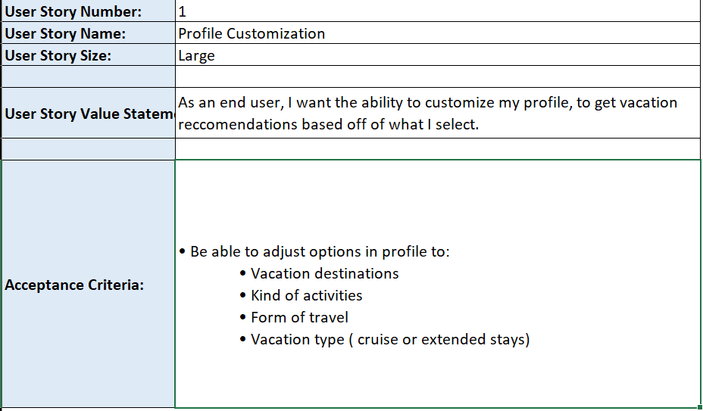

Like in many projects, there were interruptions during the development of the SNHU travel site. However, under the agile method, the team was able to overcome these obstacles and while still meeting the deadline. One of such cases was during the development of the test cases. The tester created the test cases for three of the user stories, and felt like there was more information needed, so they reached out to the product owner for clarification. After receiving the product owner, the tester revised the test cases to better suit the product's requirements.
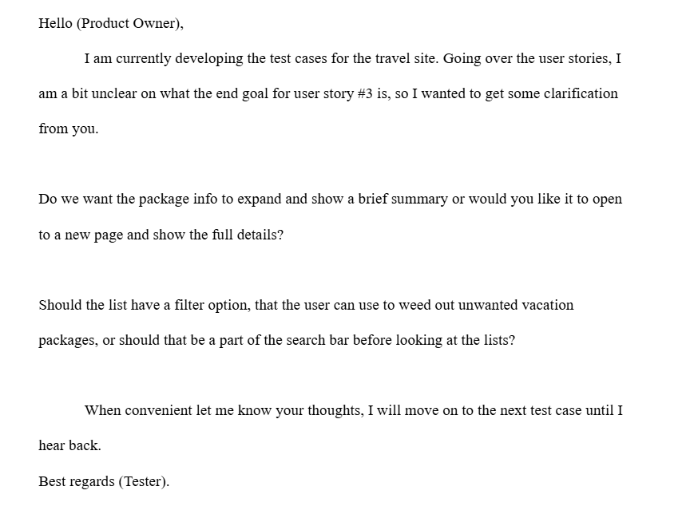
This is an example of the communication focus of the agile method and ability to make quick changes. The tester was unsure after completing their test cases, so they worked with the product owner to refine such cases, in order to provide the developers a better framework for their end of the project. A similar situation occurred with the developers, they had started developing the slideshow but were informed the direction changed to have a focus on relaxation and wellness. So the developers had to act quickly to make the proper adjustments to the slide show.
As mentioned before, communication plays a big role in the agile method, because without it, the collaborative aspect of the agile method is next to none. Activities such as the daily stand ups help foster communication, by actively giving team members a space to discuss what they have accomplished or what they have been struggling with. These meetings happen frequently and only last a limited amount of time. They help by reducing wasted and ineffective, long form meetings, by keeping things fresh and on point .Another form of communication has been the use of email across departments to get clarification for current or upcoming product features. An example of this is an email between the tester and product owner. (insert screenshot)
The tester is reviewing the user stories created by the product owner, but they are unsure of exactly what the user story is asking for. So they ask clarifying questions of what is expected of the features, so that they can make the appropriate test cases for those features.
The agile method has incorporated a multitude of tools and practices that help with organizing and estimating the product development. Looking first into the estimation practices, there are multiple practices that are used, but the ones I find particularly helpful are the burn up and burn down charts. I like these practices because they have a visual representation of where the team is currently at in the sprint and shows if they are above, below or at pace. I specifically chose to mention both forms, because they are relatively the same but use different metrics of completion. The burn up uses items completed and the burn down uses time remaining as the metric. So in certain situations, it may suit the team better to estimate based off of one of these metrics over the other.
We also discussed the tools being used in agile teams. These tools include JIRA or Azure boards, both being web based services, that allow the members of the team to stay connected and give them access to features to help them during the project's development. Features such as discussion boards, product backlogs and access to the user stories and test cases. I find these tools to be particularly helpful nowadays, as a lot of companies are transitioning to allow for their team members to work remotely and have less days in the office. Allowing them to have the same reach to communicate and view the necessary documents to complete their work.
During this project, for the SNHU travel site, the use of the agile methodology was a very effective approach. In my opinion, the use of the agile method had many pros, such as the adaptability to changes of the end goal of the product. I also think that the pros of this method include the incremental development, the use of sprints and smaller collaborative teams, which were very effective during this process of development. As for the cons, I did not experience much that I would consider to be such. However, I think for me the biggest con would have to be learning a whole new project management methodology. Albeit, the learning process was only a short duration, it did have an effect on my earlier productivity. Other than that, I did not experience much on the con side of things. Overall, I think the use of the agile method was the best possible approach to the SNHU travel site, because it really allowed for the team to face the changes head on and collaborate to overcome those obstacles.

